

**COURSE: BLDG6851 - PROJECT COST ESTIMATING**

**Semester: FALL-2022**

**PARKHILL DEVELOPMENT BUILDING 2**

**MILTON, ONTARIO – Bid Submission**

FINAL TERM PROJECT

Instructor

Mark Sagaria, P.Eng., M.Eng., MFin, LL.M.

**Submitted By**

|  |  |
| --- | --- |
| Student Name | Student Number |
| Bryan Jay Sanggalang | 40221512 |
| Darshit Rudani | 40217720 |
| Vikas Vaghasiya | 40219501 |
| Wasiuddin Mohammed | 40182192 |

Table of Contents

1.0 LETTER OF INTENT 3

2.0 ROLES & RESPONSIBILITIES 4

3.0 MASTERFORMAT 2018 TOTAL COST BREAKDOWN 5

4.0 TENDER ANALYSIS FOR CONCRETE SUPPLY 11

5.0 LIST OF ASSUMPTIONS 11

6.0 SAMPLE CALCULATIONS OF QUANTITY TAKE-OFF 12

6.1 Augered Footing 12

6.2 Trench Footing 13

6.3 Foundation Wall 13

6.4 Strip Footing 14

6.5 Slab on Grade 14

6.6 Structural Steel 15

7.0 CONCLUSION 16

8.0 REFERENCES 17

9.0 APPENDIX 18

LIST OF TABLES AND FIGURES

Table 1 – Total Cost Breakdown……………………………………………………………...5

Table 2 – Concrete Tender Analysis…..……………………………………………………..11

# LETTER OF INTENT

December 7, 2022

To: Broccolini

Project: Parkhill Development Building 2 – Milton Ontario

Subject: Letter of Intent to Bid

Greetings!

We, **BVVD Builders Inc.**, would like to formally signify our intent to bid for the construction of **Parkhill Development Building 2** to Broccolini with this letter of intent. We offer a total bid price of $5,783,304.00 for the industrial building with an estimated area of 7969.32 sqm located in Milton, Ontario. Our scope will include the following works:

* Concreting works
* Masonry works
* Steel framing and metal decking works
* Finishing works
* Thermal and moisture protection
* Equipment and specialty items installation

We believe that BVVD Inc. will bring unique value and capabilities to the project. Our company has proven its competency and integrity for the past decade as one of the leaders in building construction in Ontario. We specialize on industrial buildings and warehouses, among others. We have executed similar projects in the past years such as Etobicoke Warehouse Complex in 2015 and Sarnia Development Building Centre in 2018, just to name a few.

We are excited to meet with you to discuss your project. We look forward to doing business and build rapport between our companies.

Sincerely,

Elon Musk

Managing Director

BVVD Inc.

# ROLES & RESPONSIBILITIES

Our team is composed of experienced and highly efficient staff to manage and execute the tasks required for the completion of Parkhill Development Building 2.

**Bryan Jay Sanggalang (Structural Engineer)**

Engr. Sanggalang has 10 years of work experience in the engineering and construction industry. His main responsibilities are making quantity take-offs, calculations, and RSMeans pricing for structural steel items. He also assisted the team in summarizing the report and in some items in the concrete quantity take-offs.

**Darshit Rudani (Civil Engineer)**

Engr. Rudani has 2 years of experience in construction, structural designing, and quantity estimation. His major responsibilities are making quantity take-offs, formwork quantity, reinforcement rebar quantity and RS Means pricing.

**Vikas Vaghasiya (Civil Enineer)**

Engr. Vaghasiya has 1 years of working experience in civil engineering industry. He worked on tender documentation and quantity documentation. His major responsibilities include concrete quantity take-off, roofing quantity and RS Means pricing.

**Wasiuddin Mohammed (Civil Engineer)**

Engr. Mohammed has 3 years of experience in the construction industry. His responsibilities include quantity take-off for elements such as footing, metal roof deck, and hardware. Moreover, he did a rate analysis by Rs-means and Broccolini price sheet.

# 3.0 MASTERFORMAT 2018 TOTAL COST BREAKDOWN

Table 1 – Total Cost Breakdown

|  |  |  |  |  |
| --- | --- | --- | --- | --- |
| **Description** | **Quantity** | **Pricing Unit** | **Sub Cost** | **Total Cost** |
| **03 00 00 Concrete** |  |  |  | $2,586,113.92 |
| **03 10 00 Concrete Forming and Accessories** |  |  |  | $54,199.08 |
| **03 11 00 Concrete Forming** |  |  |  | $54,199.08 |
| **03 11 13 Formwork** |  |  |  | $54,199.08 |
| Strip Footings | 118.15 | sfca | $9.00 | $1,063.35 |
| Piers | 436.26 | sfca | $9.00 | $3,926.34 |
| Foundation Walls Standard | 5,467.71 | sfca | $9.00 | $49,209.39 |
| **03 20 00 Concrete Reinforcing** |  |  |  | $56,856.96 |
| **03 21 00 Reinforcing Steel** |  |  |  | $56,856.96 |
| **03 21 00 Reinforcing Steel** |  |  |  | $56,856.96 |
| Reinforcing Steel 10M S/I | 400.00 | kg | $2.88 | $1,152.00 |
| Reinforcing Steel 15M S/I | 12,610.00 | kg | $2.88 | $36,316.80 |
| Reinforcing Steel 20M S/I | 584.00 | kg | $2.88 | $1,681.92 |
| Reinforcing Steel 25M S/I | 6,148.00 | kg | $2.88 | $17,706.24 |
| Reinforcing Steel 30M S/I | 0.00 | kg | $0.00 | $0.00 |
| Reinforcing Steel 35M S/I | 0.00 | kg | $0.00 | $0.00 |
| **03 30 00 Cast-in-Place Concrete** |  |  |  | $777,806.94 |
| **03 31 00 Structural Concrete** |  |  |  | $777,806.94 |
| **03 31 00 Concrete Supply** |  |  |  | $777,806.94 |
| 25 MPA - Footing | 3.70 | m3 | $131.21 | $485.70 |
| 25 MPA - Foundation Walls | 5.78 | m3 | $142.68 | $824.24 |
| 25 MPA - Interior Augured Footings | 129.46 | m3 | $137.75 | $17,833.31 |
| 25 MPA - Slabs | 1,235.30 | m3 | $95.02 | $117,378.21 |
| 25 MPA with air - Perimeter Augured Footings | 431.04 | m3 | $137.75 | $59,375.31 |
| 25 MPA with air - Foundation Walls | 71.64 | m3 | $142.68 | $10,221.85 |
| 25 MPA with air - Trench Footing | 138.02 | m3 | $131.21 | $18,109.00 |
| 25 MPA with air - Piers | 7.82 | m3 | $141.35 | $1,105.63 |
| Environmental Cost, Fuel Surcharge & Carbon Tax | 2,022.76 | m3 | $9.00 | $18,204.80 |
| Steel Fibres 15kg/m3 | 18,529.56 | kg | $27.50 | $509,562.90 |
| High Range Super Plasticizer (Required with Steel Fibres) | 1,235.30 | m3 | $20.00 | $24,706.00 |
| **03 35 00 Concrete Finishing** |  |  |  | $146,618.44 |
| **03 35 00 Concrete Finishing** |  |  |  | $146,618.44 |
| Floor Hardener Traprock 60lbs/100sf | 85,321.83 | sf | $0.75 | $63,991.37 |
| Pour / Finish 6" Slab on Grade | 85,321.83 | sf | $0.70 | $59,725.28 |
| Sawcuts @ slab on grade | 17,962.00 | lf | $0.80 | $14,369.60 |
| Wet Cure Slab on Grade > film | 85,321.83 | sf | $0.10 | $8,532.18 |
| **03 40 00 Precast Concrete** |  |  |  | $1,550,632.50 |
| **03 45 00 Precast Architectural Concrete** |  |  |  | $1,550,632.50 |
| **03 45 13 Faced Architectural Precast Concrete** |  |  |  | $1,550,632.50 |
| Insulated Precast Concrete Panel System | 34,458.50 | sf | $45.00 | $1,550,632.50 |
| **04 00 00 Masonry** |  |  |  | $15,276.93 |
| **04 20 00 Unit Masonry** |  |  |  | $15,276.93 |
| **04 22 00 Concrete Unit Masonry** |  |  |  | $15,276.93 |
| **04 22 00 Masonry** |  |  |  | $15,276.93 |
| Fire-rated CMU Block 190mm - 2 hrs | 1,081.17 | sf | $14.13 | $15,276.93 |
| **05 00 00 Metals** |  |  |  | $1,115,572.12 |
| **05 10 00 Structural Metal Framing** |  |  |  | $886,645.90 |
| **05 12 00 Structural Steel Framing** |  |  |  | $886,645.90 |
| **05 12 00 Structural Steel** |  |  |  | $886,645.90 |
| Column HSS 254x254x10 | 15,912.20 | kg | $4.98 | $79,175.53 |
| Column HSS 254x254x13 | 5,623.18 | kg | $3.84 | $21,573.96 |
| Column HSS 305x305x10 | 51,026.03 | kg | $4.11 | $209,815.16 |
| Continuous Angle L127x76x10 | 6,022.17 | kg | $7.87 | $47,394.47 |
| Bracing Angles L76x76x6 | 1,498.98 | kg | $0.45 | $680.40 |
| Girts HSS 203x203x6 | 4,878.95 | kg | $5.23 | $25,533.58 |
| Girts HSS 203x203x10 | 2,639.95 | kg | $3.59 | $9,481.55 |
| Girts HSS 203x203x13 | 1,143.43 | kg | $2.77 | $3,168.98 |
| Girts W360x33 | 1,579.79 | kg | $3.43 | $5,418.83 |
| X Bracing HSS 203x203x6 | 5,050.01 | kg | $5.23 | $26,428.78 |
| X Bracing HSS 254x254x13 | 1,932.27 | kg | $4.89 | $9,442.59 |
| Beam W200x27 | 3,623.76 | kg | $4.09 | $14,828.80 |
| Beam W250x33 | 4,807.50 | kg | $3.43 | $16,490.15 |
| Beam W360x33 | 4,522.50 | kg | $3.43 | $15,512.59 |
| Beam W410x39 | 1,364.77 | kg | $3.08 | $4,210.08 |
| Beam W410x46 | 337.49 | kg | $3.06 | $1,034.39 |
| Beam W460x52 | 1,638.77 | kg | $3.08 | $5,054.43 |
| Beam W460x60 | 508.82 | kg | $3.03 | $1,542.66 |
| Beam W760x134 | 7,505.22 | kg | $3.11 | $23,358.44 |
| Beam W840x176 | 37,251.93 | kg | $2.82 | $105,004.68 |
| Beam W920x201 | 25,203.59 | kg | $2.81 | $70,921.15 |
| Beam W920x238 | 4,274.94 | kg | $2.97 | $12,683.41 |
| OWSJ 900mm | 94,436.64 | kg | $1.67 | $158,068.19 |
| ALLOWANCE - Base plates, gusset plates, connections, bolts, etc. (2% of total structural steel weight) | 5,655.66 | kg | $3.51 | $19,823.09 |
| **05 30 00 Metal Decking** |  |  |  | $228,926.22 |
| **05 31 00 Steel Decking** |  |  |  | $228,926.22 |
| **05 31 23 Steel Decking** |  |  |  | $228,926.22 |
| Metal Roof Deck @ Main Roof | 91,119.47 | sf | $2.49 | $226,887.48 |
| Metal Roof Deck @ Entrance Canopies | 818.77 | sf | $2.49 | $2,038.74 |
| **06 00 00 Wood, Plastics, and Composites** |  |  |  | $4,632.96 |
| **06 10 00 Rough Carpentry** |  |  |  | $4,632.96 |
| **06 11 00 Wood Framing** |  |  |  | $4,632.96 |
| **06 11 10 Blocking** |  |  |  | $4,632.96 |
| 2' x 10' x 12' @ Parapet | 1,272.79 | lf | $3.64 | $4,632.96 |
| **07 00 00 Thermal and Moisture Protection** |  |  |  | $323,964.37 |
| **07 40 00 Roofing and Siding Panels** |  |  |  | $119,521.82 |
| **07 42 13 Metal Wall Panels** |  |  |  | $119,521.82 |
| **07 42 13.20 Aluminum Siding Panels** |  |  |  | $8,621.22 |
| Aluminum Composite Panel Alucobond System SL2000 - Color Red @ Canopy | 694.14 | sf | $6.21 | $4,310.61 |
| Aluminum Soffits Alucobond System SL2000 - Color Red @ Canopy | 694.14 | sf | $6.21 | $4,310.61 |
| **07 42 13.30 Steel Siding** |  |  |  | $110,900.60 |
| Insulated Metal Panels (Type W2) - Grey | 5,282.72 | sf | $17.86 | $94,349.38 |
| Insulated Metal Panels (Type W2) - White | 926.72 | sf | $17.86 | $16,551.22 |
| **07 50 00 Membrane Roofing** |  |  |  | $198,984.79 |
| **07 51 00 Built-Up Bituminous Roofing** |  |  |  | $198,984.79 |
| **07 51 13.20 Built-Up Roofing Systems** |  |  |  | $198,984.79 |
| Roof R1 (Bldg) - 4 ply built up roofing over R30 rigid insulation over vapor retarder - Note 301/A3.2 | 85,321.83 | sf | $2.31 | $197,093.43 |
| Roof R2 (Canopy) - Single ply membrane flashing | 818.77 | sf | $2.31 | $1,891.36 |
| **07 65 00 Flexible Flashing** |  |  |  | $5,457.77 |
| **07 65 10 Sheet Metal Flashing** |  |  |  | $5,457.77 |
| **07 65 10 Sheet Metal Flashing** |  |  |  | $5,457.77 |
| Metal cap flashing w/ cont. metal starter strip @ IMP Parapet | 509.12 | sf | $5.36 | $2,728.88 |
| Metal cap flashing w/ cont. metal starter strip @ Parapet Precast | 509.12 | sf | $5.36 | $2,728.88 |
| **08 00 00 Openings** |  |  |  | $1,064,245.46 |
| **08 10 00 Doors and Frames** |  |  |  | $5,487.57 |
| **08 11 00 & 08 13 00 Metal Doors and Frames** |  |  |  | $5,487.57 |
| **08 11 13 & 08 13 13 Metal Doors and Frames** |  |  |  | $5,487.57 |
| Hollow Metal Door - 3-2 x 7-0 | 9 | ea | $404.92 | $3,644.28 |
| Hollow Metal Frame - 3-2 x 7-0 | 9 | ea | $204.81 | $1,843.29 |
| **08 30 00 Specialty Doors and Frames** |  |  |  | $41,413.00 |
| **08 33 00 Coiling Doors and Grilles** |  |  |  | $41,413.00 |
| **08 33 23 Sectional Overhead Coiling Doors** |  |  |  | $41,413.00 |
| Overhead Door 12 x 14' Type SD2 | 2 | ea | $4,550.18 | $9,100.36 |
| Overhead Door 9 x 10' Type SD1 | 12 | ea | $2,692.72 | $32,312.64 |
| **08 40 00 Entrances, Storefronts, and Curtain Walls** |  |  |  | $509,645.82 |
| **08 42 00 Entrances** |  |  |  | $10,347.76 |
| **08 42 26 All-Glass Entrances** |  |  |  | $10,347.76 |
| Aluminum Entrance Door (Double Door) w/ Tempered Glazing & Hardware | 4 | ea | $2,586.94 | $10,347.76 |
| **08 44 00 Curtain Wall and Glazed Assemblies** |  |  |  | $499,298.06 |
| **08 44 13 Glazed Aluminum Curtain Walls** |  |  |  | $499,298.06 |
| Alum Curtain Wall 1" Insulated Tempered Glass - Vision & Spandrel Panels | 6,712.80 | sf | $74.38 | $499,298.06 |
| **08 70 00 Hardware** |  |  |  | $8,401.00 |
| **08 71 00 Door Hardware** |  |  |  | $8,401.00 |
| **08 71 20 Hardware** |  |  |  | $8,401.00 |
| Hinges Per Door | 27 | ea | $43.56 | $1,176.12 |
| Door Stop W1276 CCS | 9 | ea | $52.00 | $468.00 |
| Threshold 200D | 13 | ea | $66.43 | $863.59 |
| Standard Door Closer - 8581 BF | 9 | ea | $288.33 | $2,594.97 |
| Door Shoe 216DV | 9 | ea | $198.40 | $1,785.60 |
| Door Seals S88 | 9 | ea | $34.32 | $308.88 |
| Latch Guard LP2 | 9 | ea | $133.76 | $1,203.84 |
| **09 00 00 Finishes** |  |  |  | $7,403.87 |
| **09 20 00 Plaster and Gypsum Board** |  |  |  | $5,390.68 |
| **09 21 00 Plaster and Gypsum Board Assemblies** |  |  |  | $5,390.68 |
| **09 21 16 Gypsum Board Assemblies** |  |  |  | $5,390.68 |
| Drywall Partition type P2 - 2hr separation | 786.96 | sf | $6.85 | $5,390.68 |
| **09 90 00 Painting and Coating** |  |  |  | $2,013.19 |
| **09 91 00 Painting** |  |  |  | $2,013.19 |
| **09 91 23 Interior Painting** |  |  |  | $2,013.19 |
| Paint Door & Frame 2 coats - Single door | 9 | ea | $75.04 | $675.36 |
| Drywall Paint 2 coats @ P2 wall type (both sides) | 1,573.92 | sf | $0.85 | $1,337.83 |
| **11 00 00 Equipment** |  |  |  | $121,932.00 |
| **11 10 00 Vehicle and Pedestrian Equipment** |  |  |  | $121,932.00 |
| **11 13 00 Loading Dock Equipment** |  |  |  | $121,932.00 |
| **11 13 19 Stationary Loading Dock Equipment** |  |  |  | $121,932.00 |
| Loading Dock Equipment - hydraulic | 12.00 | ea | $10,161.00 | $121,932.00 |
| ***SUBTOTAL 1: DIRECT COSTS*** | | | | $5,117,209.62 |
| ***General Conditions (4.5%)*** | | | | $230,274.43 |
| ***SUBTOTAL 2*** | | | | $5,347,484.05 |
| ***Construction Contingency (3%)*** | | | | $160,424.52 |
| ***SUBTOTAL 3*** | | | | $5,507,908.57 |
| ***Fee (5%)*** | | | | $275,395.43 |
| ***GRAND TOTAL*** | | | | $5,783,304.00 |

## 4.0 TENDER ANALYSIS FOR CONCRETE SUPPLY

Project Name: Parkhill Development Building 2

Date: December 7, 2022

Table 2 – Concrete Tender Analysis

|  |  |  |  |  |  |  |
| --- | --- | --- | --- | --- | --- | --- |
|  | | | SUBTRADE #1 | | SUBTRADE #2 | |
| Items | Qty | Unit | Unit Rate | Total Cost | Unit Rate | Total Cost |
| 25MPa Concrete in Footing | 710.04 | m3 | $107.00 | $75,974.28 | $112.00 | $79,524.48 |
| 25MPa Concrete in Foundation | 77.42 | m3 | $116.00 | $8,980.72 | $117.00 | $9,058.14 |
| 25MPa Concrete in SOG | 1235.3 | m3 | $127.00 | $156,883.10 | $122.00 | $150,706.60 |
| Environmental Cost, Fuel Surcharge & Carbon Tax | 2022.76 | m3 | $8.65 | $17,496.87 | $9.00 | $18,204.84 |
| Steel Fibres 15kg/m3 | 18529.56 | kg | $5.67 | $105,062.61 | $5.33 | $98,762.55 |
| High Range Super Plasticizer (Required with Steel Fibres) | 1235.3 | m3 | $30.00 | $37,059.00 | $22.00 | $27,176.60 |
|  |  |  |  |  |  |  |
| TOTAL |  |  |  | $401,456.58 |  | $383,433.21 |

Based on the tender analysis, Subtrade #2 will have the lower cost. Therefore, we will select Subtrade #2. Unit rate for material cost by subtrade #2 will be used in this estimate. No mark-up will be applied.

## 5.0 LIST OF ASSUMPTIONS

1. For 03 31 00 Concrete Supply – 25 MPa with Air Foundation Walls, since FGL varies from 211.53 to 211.58 around the building the average elevation of 211.56m was used.

2. Loose items such as angles for OWSJ connections, clip angles and back slopes angles are included in the allowance for connection quantities.

3. For steel sections, standard weights were taken from CISC steel shapes database retrieved from https://www.dlubal.com/.

4. For reinforcing bar unit weight (kg/m3) is calculated using d2/162.

5. Pricing for labor and equipment cost of augered footings are based on deep continuous footing, direct chute 03310570 – Placing Concrete.

6. Pricing for labor and equipment cost of 650mm & 850mm piers are based on columns, square or round, 900mm thk, pumped 03310570 – Placing Concrete.

7. Conversion for steel weight is 1000 kg = 1 metric ton.

8. Quantities from the calculation that is in square meter are converted to square feet to match the master format breakdown.

9. RS Means pricing were adjusted to match the units in the Brocolinni breakdown (i.e. structural steels, membrane roofing)

## 

## 6.0 SAMPLE CALCULATIONS OF QUANTITY TAKE-OFF

## 6.1 Augered Footing

Augered Footing- 25 MPA (Concrete supply)

Diameter = 2440mm, Height = 1400mm, No. of footing F1= 7

Area of footing = ∏ x (d/2)2 = ∏ x (2.44/2)2 = 4.68 m2

The volume of concrete = Area x Height = 4.68 m2 x 1.4m = 6.552 m3

Total quantity for 25 MPA – interior Augured footing F1

Vol.F1 = No. of Footing x Volume = 7 x 6.552 m3 =45.864 m3

Total volume including Wastage 10% = 1.1 x 45.864 **= 50.45 m3**

25 MPA with air Piers (Concrete Supply).

Length = 800mm; width = 800mm; Height =1050mm,

No of Peir1 = 8

Total volume = No of piers x Length x width x height = 8 x 0.8 x 0.8 x 1.05

Total volume = = 5.376 m3

**Total volume including Wastage 3%** **= 1.03 x 5.376** m3 **= 5.537 m3**

Augured Footing- Reinforcement

25M vertical

Length of one rebar = 1.4m, # of bars = 18, Unit Weight = 3.92kg/m3, # of F1 footing = 12

Total weight = 18 x 1.4 x 3.92 x 12 = 1,185.45 kg

15M ties @ 300mm O/C

Length of one rebar = πd = 3.14 x (2.44 – 2 x 0.075) = 7.19m

# Of bars = (1.4 / 0.3 + 1) = 6, Unit Weight = 1.58kg/m3, # of F1 footing = 12

Total weight = 7.19 x 6 x 1.58 x 12 = 817.93 kg

## 6.2 Trench Footing

Interior Wall Perimeter = 5406 + 4166 + 6959 + 200 + 5406 + 5406 = 27543mm

Less 5d (4+1 x d to include the middle wall) = 500 mm

PCLint.wall = 27543mm + 500mm = 28043mm/1000 = 28.043m

Width of footing = 600 mm; Thickness = 200

Total Volume = 28.043m x 0.2m x 0.6m = 3.37 m3

Total Volume + 10% wastage factor = 3.70 m3

**Reinforcement**

15M Bottom Bar

Length of one rebar = 388.212m, # of bars = 2, Unit Weight = 1.58kg/m3

Total weight = 388.212 x 2 x 1.58 = 1226.74 kg

## 6.3 Foundation Wall

Concrete Supply

Interior wall for Electrical and sprinkler room

PCLint.wall = 28.043m

Width of wall = 200 mm; Height = 1000

Total Volume = 28.043m x 0.2m x 1m = 5.61 m3

Total Volume + 3% wastage factor = 5.78 m3

Formwork

West side wall

Interior wall length = 131.244 – 2 x 0.23= 130.784m

Formwork for west wall = 131.244 x 1.35 + 130.784 x 1.3 = 353.737 m2 = 3,807.59 sf

North, East, South and West Recess wall

Interior wall length = 257.408 – 3 x 0.23 = 256.718m

Formwork = 257.408 x 0.3 + 256.718 x 0.3 = 154.23 m2 = 1,660.12 sf

Total Foundation wall formwork = 3,807.59 + 1,660.12

Total Foundation wall formwork = 5,467.71 sf

Reinforcement

Horizontal 15M cont. top,

Length of one rebar = 257.408m, # of bars = 4, Unit Weight = 1.58kg/m3

Total weight = 257.408 x 4 x 1.58 = 1,626.81 kg

15M Dowel @ 400mm O/C typical section

Length of one rebar = 0.75m, # of bars = (257.408/0.4 + 1) = 655, Unit Weight = 1.58kg/m3

Total weight = 0.75 x 655 x 1.58 = 776.175 kg

## 6.4 Strip Footing

Concrete Supply

Interior wall for Electrical and sprinkler room

Width of footing = 600 mm; Thickness = 200 mm

Total Volume = 28.043m x 0.6m x 0.2m = 3.37 m3

Total Volume + 10% wastage factor = 3.7 m3

Formwork

Outer Perimeter = [2 x (5406+400) + 6959 + 4166 + (5 x 200)] = 23,737mm = 23.737m

Interior Perimeter = [4 x (5406 - 200) + 4166 – 400 + 6959 - 400] = 31,149mm = 31.149m

Formwork = 31.149 x 0.2 + 23.737 x 0.2 = 10.9772 m2

Formwork = 118.15 sf

Reinforcement

15M Bottom Bar

Length of one rebar = 30.349m, # of bars = 2, Unit Weight = 1.58kg/m3

Total weight = 30.349 x 2 x 1.58 = 95.90 kg

## 6.5 Slab on Grade

Concrete supply – slab area is divided into no. of parts

Volume of concrete (1) = Area (1) x Depth = (131.244 x 30.271) x 0.15 = 595.93m3

Volume of concrete in square feet= (595.93 x 10.764 = 6414.50 cu. ft.

Similarly,

V2 = 725.91 m3, V3 = 4560.88 m3 ,V4 = 370.62 m3 ,V5 = 582.2 m3 ,V6 = 251.92 m3 ,

Total volume of slab = 6411.29 + 725.91 +4560.88 + 370.62 + 582.20 +251.92

= 12902 cu. ft

Total volume of slab = 1199.24 cu. m

Placing of Finishing

Area (1) = Length x Breadth = 131.244 x 30.271 x 10.764 = 42741.157 sf

Similarly,

A2 = 725.91 sf, A3 = 4560.88 sf, A4 = 370.62 sf, A5 = 582.2 sf, A6 = 251.92 sf,

Total Area = 42741.91 +725.91 +4560.88 +370.62 +582.2 +251.92

= 49233.44 sf

## 6.8 Structural Steel

Column HSS 254x254x10

Length = 11.143m

Weight of Column = 71.40 kg/m

No. of Columns = 20

Total weight of Column HSS 254x254x10 = 20 x 11.143m x 71.40kg/m = 15,912.20 kg

Beam W460x52

|  |  |  |  |  |  |  |  |  |
| --- | --- | --- | --- | --- | --- | --- | --- | --- |
| Mark | Section | Type | Col-Col  Length | Col 1 | Col 2 | Length* | Qty | Length |
| 4B2 | Beam W460x52 | Beam | 7816 | 305 | 305 | 7511 | 1 | 7.51 |
| 4B7 | Beam W460x52 | Beam | 8463 | 305 | 305 | 8158 | 1 | 8.16 |
| 4B6 | Beam W460x52 | Beam | 8168 | 305 | 305 | 7863 | 1 | 7.86 |
| 4B5 | Beam W460x52 | Beam | 8167 | 305 | 305 | 7862 | 1 | 7.86 |
| Total Length | | | | | | | | 31.39 |

*Length = Col-col length – (Col 1/2 + Col 2/2)

Total weight of Beam W460x52 = 31.39m x 52.2 kg/m = 1,638.56 kg

## 7.0 CONCLUSION

Parkhill Development project is an industrial building structure with a surface area of 7969.32 m2 located in Milton, Ontario. The quantities were calculation based on the provided construction drawings and best practices in estimation. For the pricing of items, RS Means online database and the provided Broccolini price lists were utilized. Based on the provided quotes and supply prices, the tender analysis for the supply of concrete is completed. It is concluded that Subtrade #2 will be adapted for the concrete supply material cost since they are quoting the lower prices. The majority of the bid amount is allocated to concrete works and structural steel framing and metal decking works. Building openings and roller doors also added significant amount.

BVVD Builders Inc. are putting in a bid to build this facility as a general contractor. For the ensuing project, a lump-sum contract will be employed. A total project cost of $5,783,304.00 was offered to the Client which includes direct costs, indirect charges, and markups. With the cost projection, the first phase of the of bid process was completed.

## 8.0 REFERENCES

Plotner, S.C., 2017. RS Means Building Construction Cost Data, 74th Annual Edition. RS Means.

RS Means from Gordian. Canadian Construction Cost Data. RS Means (Version 66FTV1). Retrieved from <https://www.rsmeansonline.com/>

## 9.0 APPENDIX

*Detailed Calculation of Quantities*

Steel Quantities and RSmeans Pricing conversion

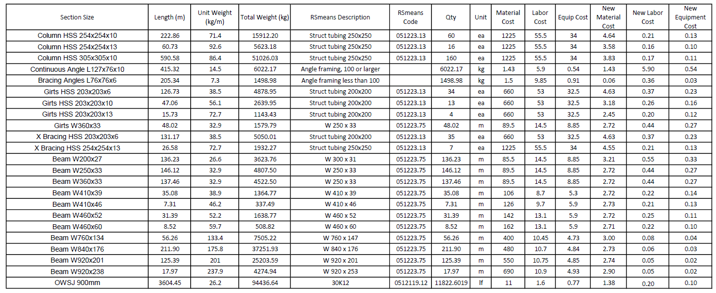

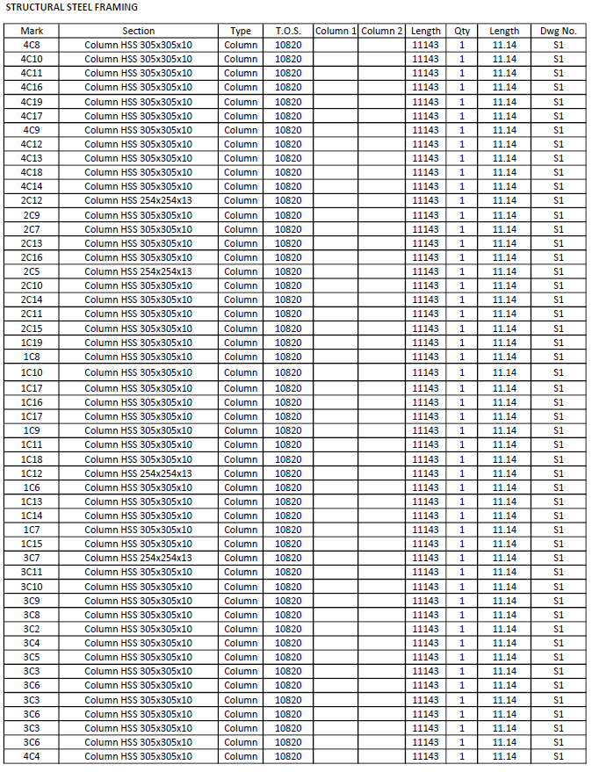

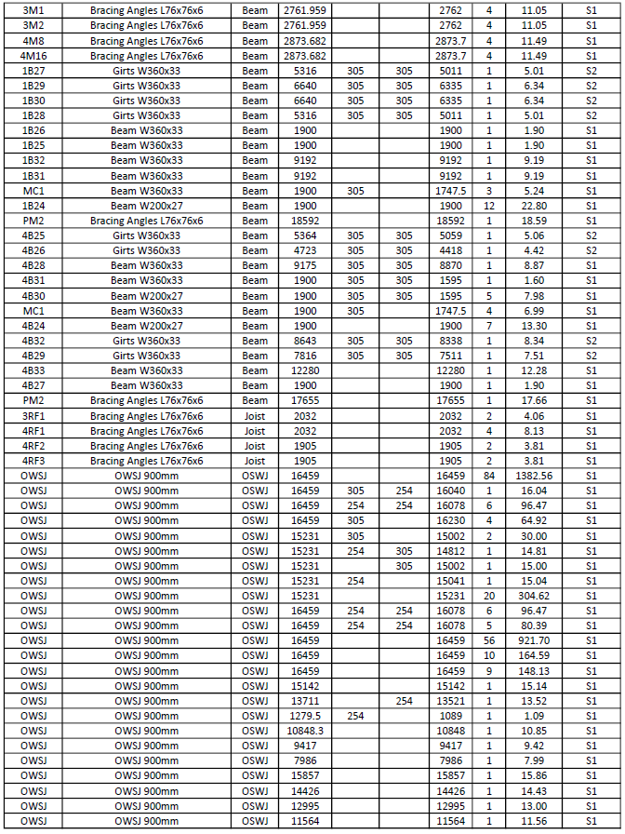

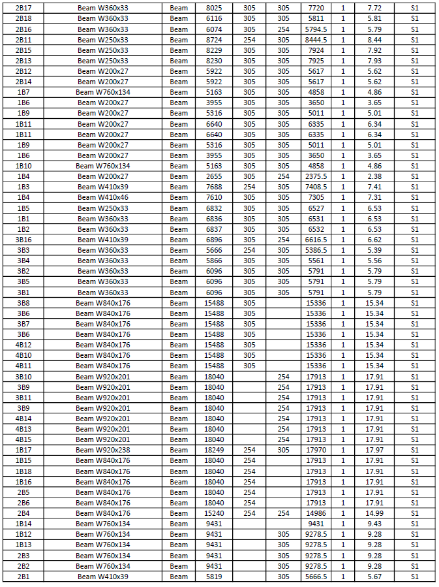

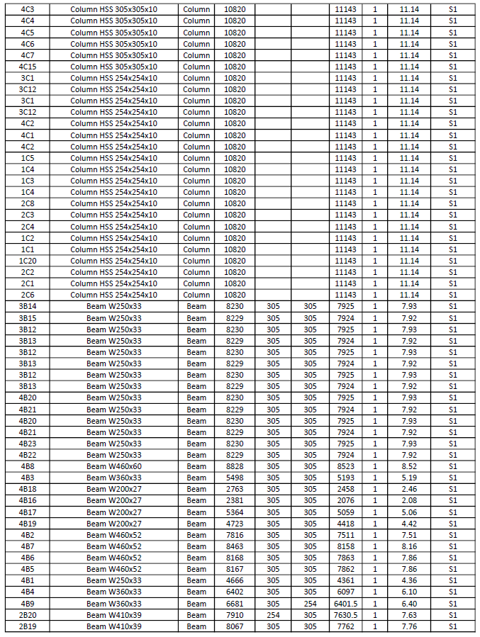

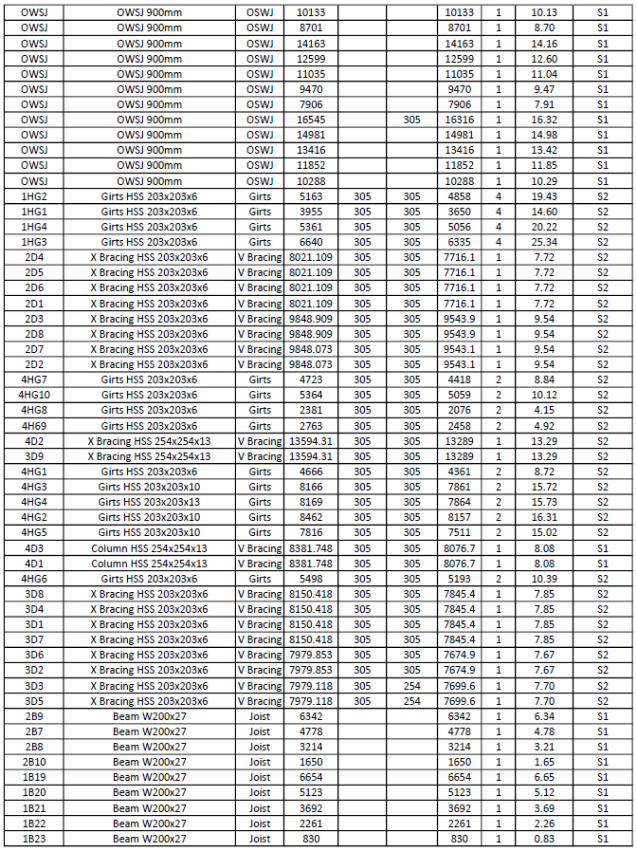

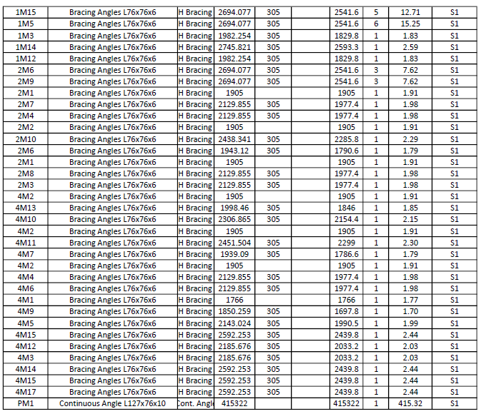

|  |
| --- |
| 03 31 00 Concrete Supply |
|  |

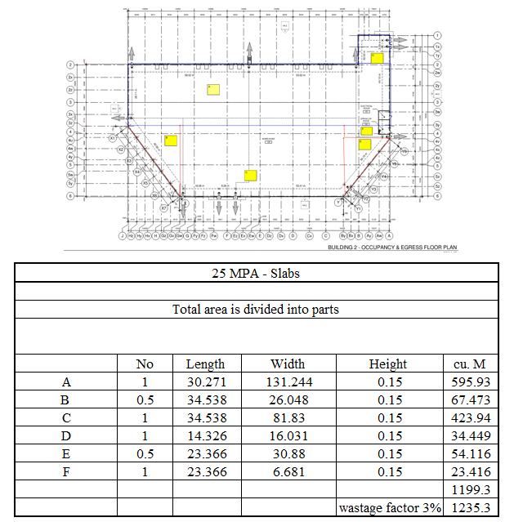

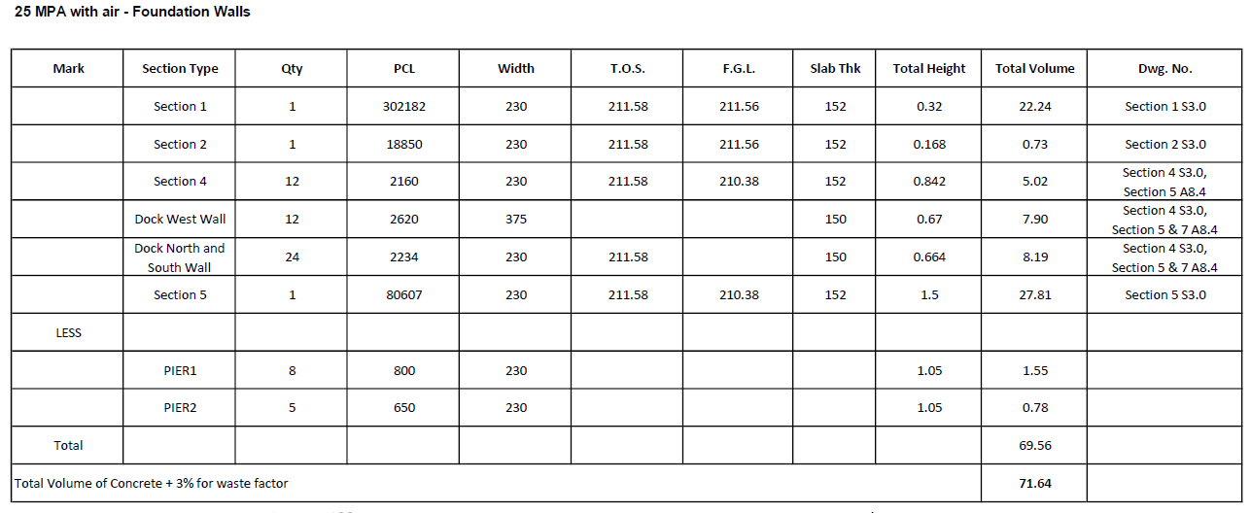

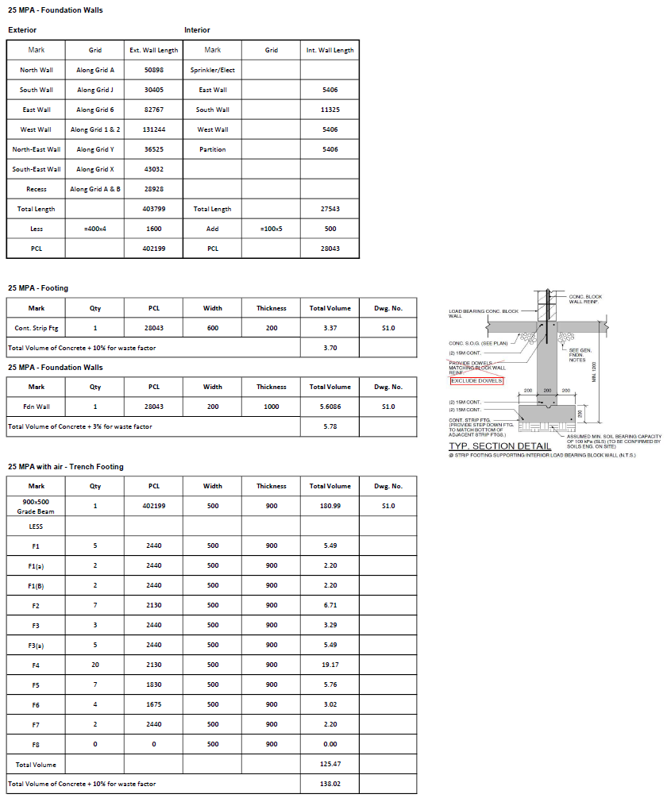

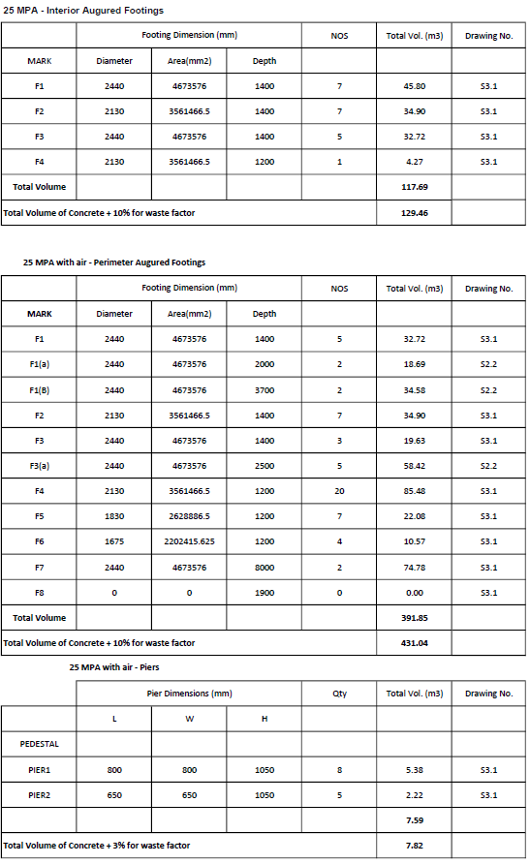

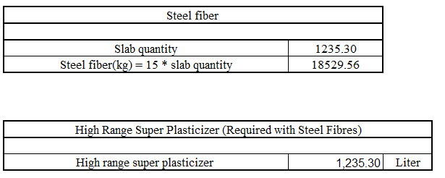

|  |
| --- |
| 03 35 00 Concrete Finishing |

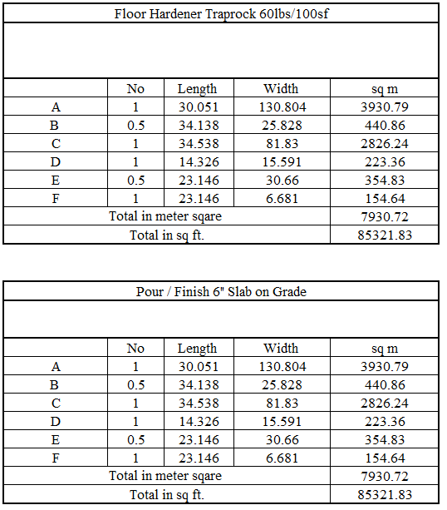

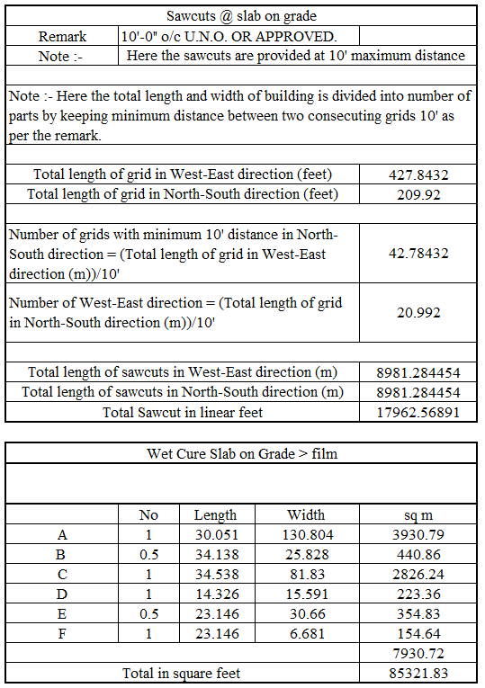

|  |
| --- |
| 04 22 00 Masonry |

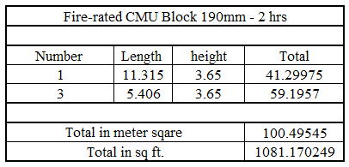

|  |
| --- |
| 06 11 10 Blocking |

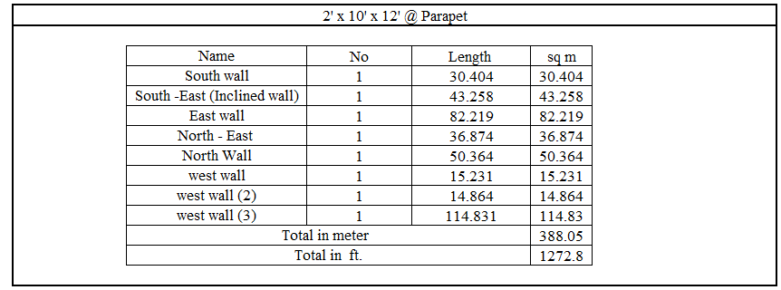

|  |
| --- |
| 07 42 13.20 Aluminum Siding Panels |
|

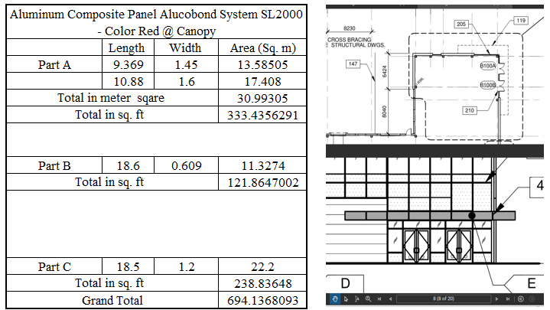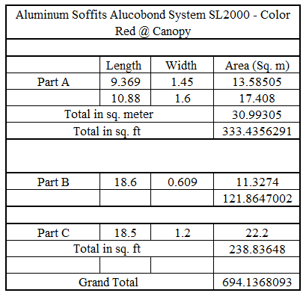

|  |
| --- |
| 07 42 13.30 Steel Siding |

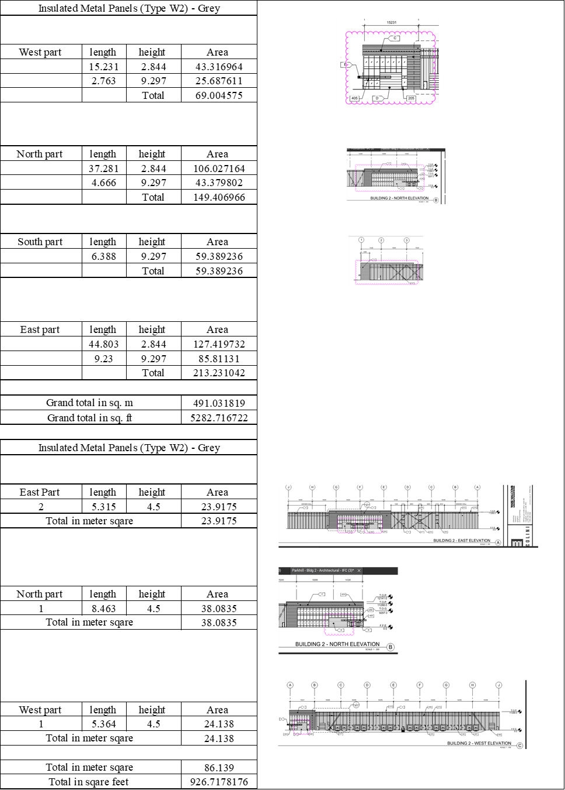

|  |
| --- |
| 07 51 13.20 Built-Up Roofing Systems |
|

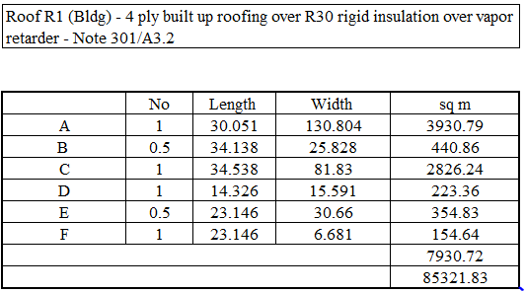

|  |
| --- |
| 08 44 13 Glazed Aluminum Curtain Walls |
|

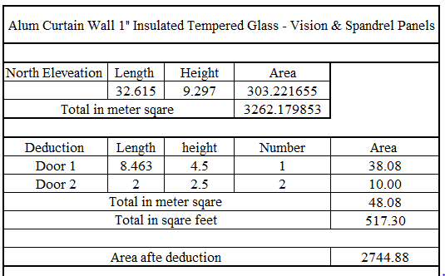

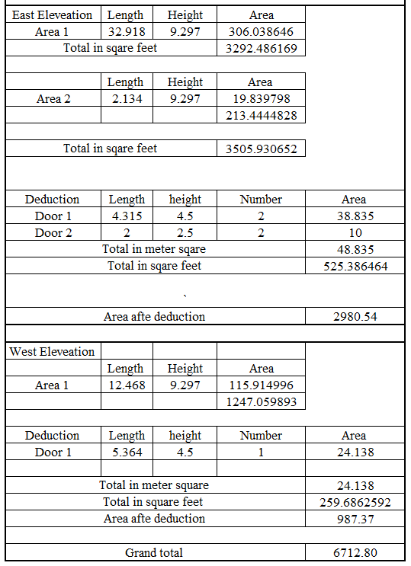

|  |
| --- |
| 09 21 16 Gypsum Board Assemblies |

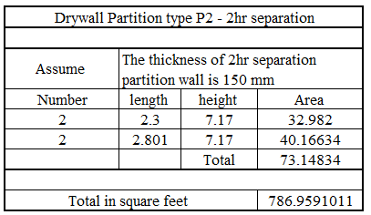

|  |
| --- |
| 09 91 23 Interior Painting |

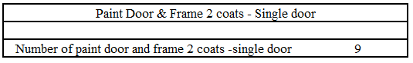

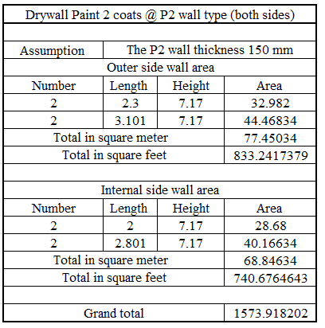

**03 11 00 Concrete Forming**

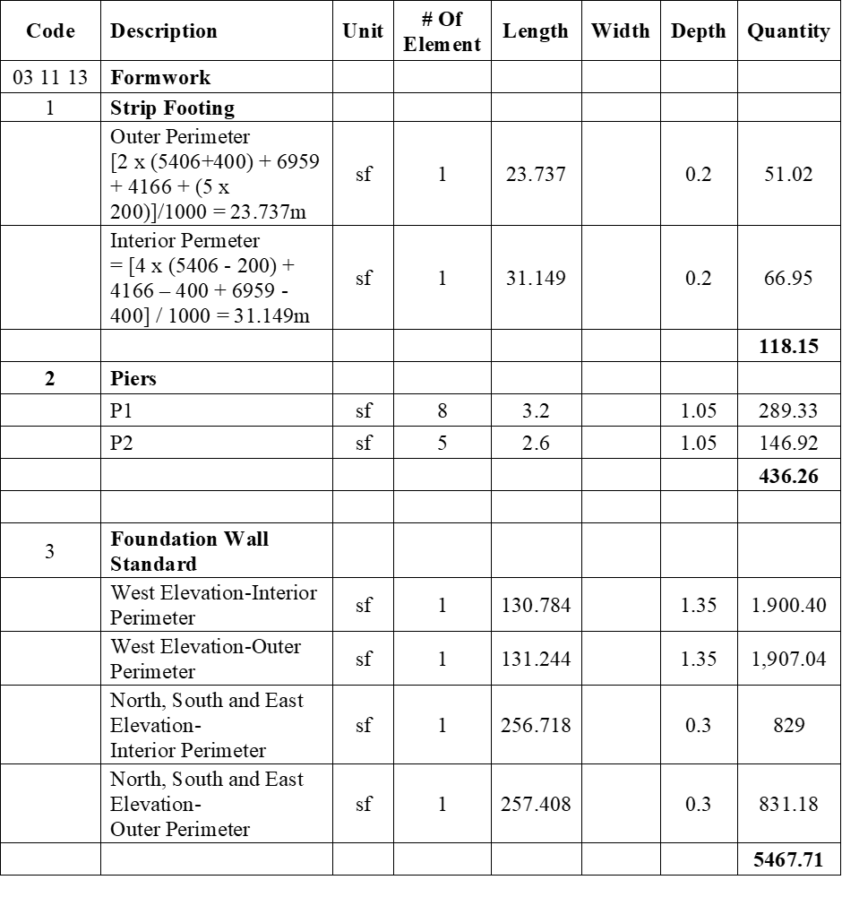

**03 21 00 Reinforcing Steel**

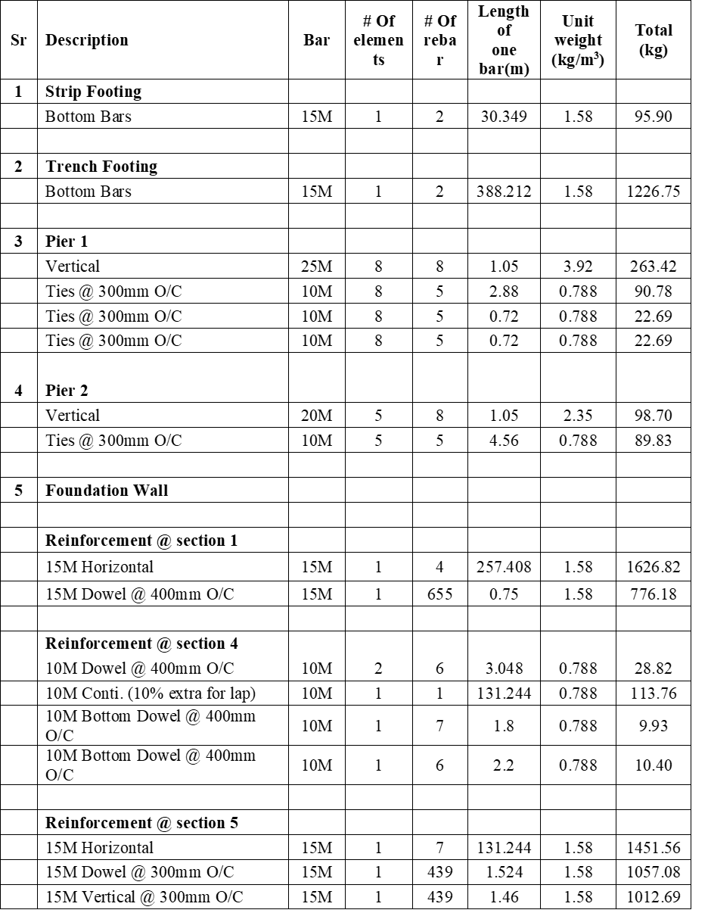

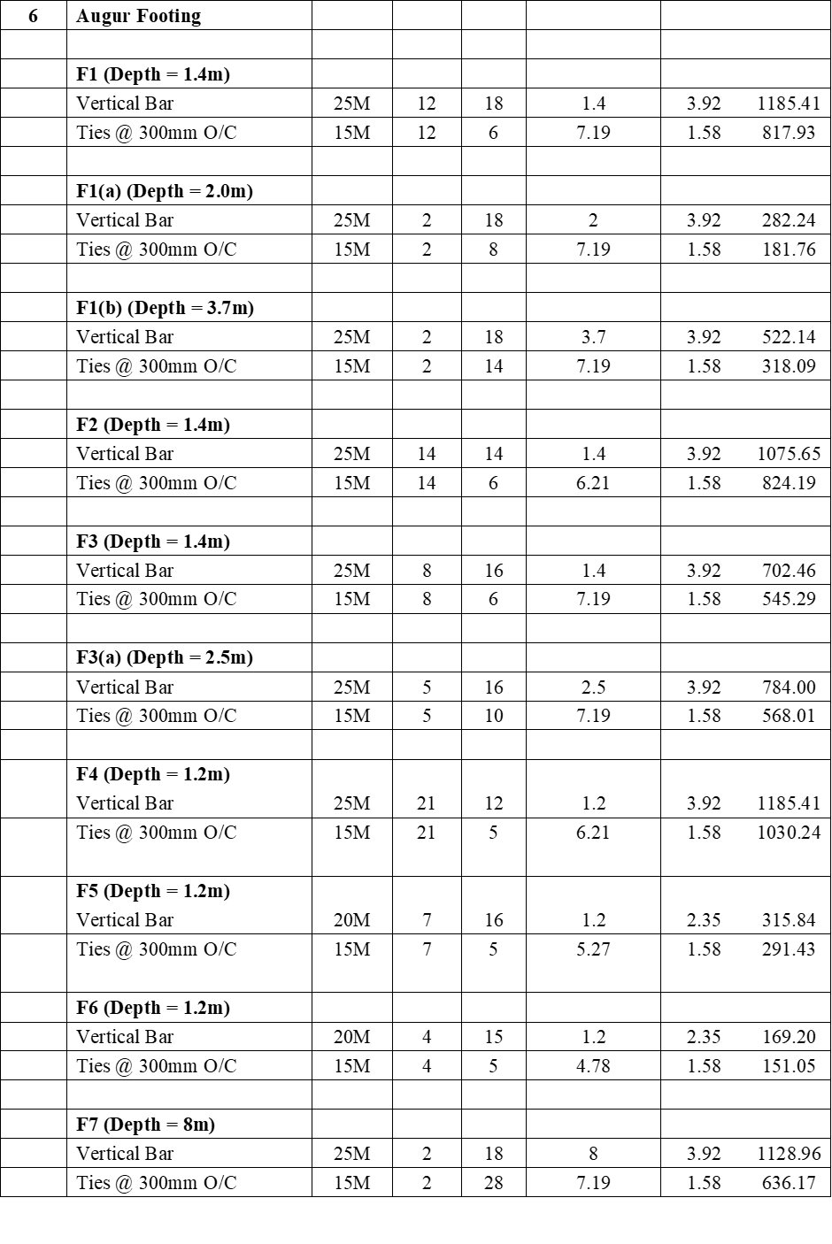

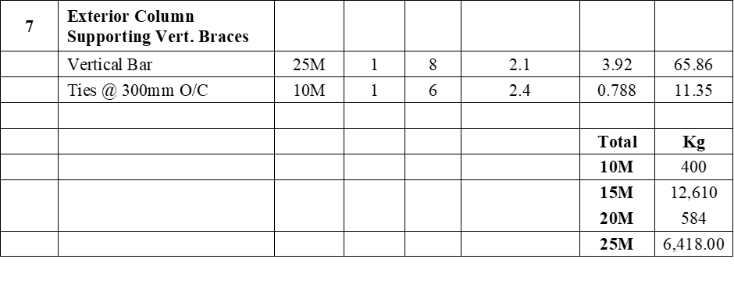

**03 45 13 Faced Architectural Precast Concrete**

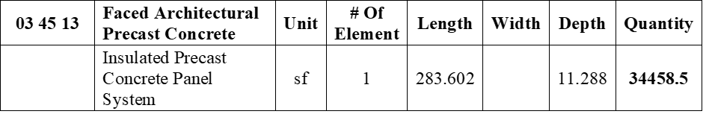

**05 31 23 – steel Decking**

**Metal Roof Decking**

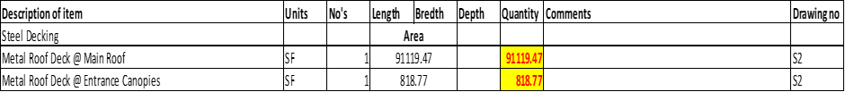

**08 11 13 & 08 13 13 -Openings**

**Metal doors and Frames**

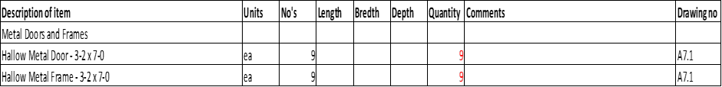

**08 33 23 – Sectional overhead coiling Doors**

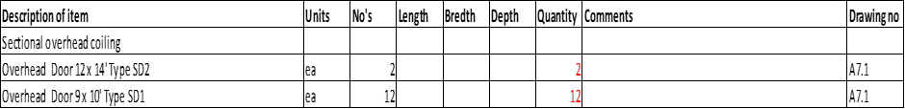

**08 42 26 -All - glass Entrances**

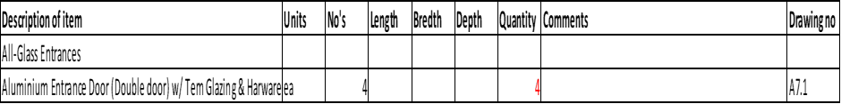

**08 70 00 –Hardware**

